Project Documentation
Cook Book: Your Culinary Companion

- Introduction

- Project Title: Cook Book: Your Culinary Companion

- Team ID: NM2025TMID40014

- Team Leader: LATHICCA S [sac2427csc5483@ssacollegechennai.com]
- Team Member:
KOMALA.Y [sac2427csc5383@ssacollegechennai.com]
LISHA.E
[sac2427csc5770@ssacollegechennai.com]
MANJULA.C
[sac2427csc5447@ssacollegechennai.com]

2. Project Overview
- Purpose: Cook Book is a web application that allows users to explore, upload, and manage recipes. It provides personalized collections, search filters, and a seamless cooking experience.

- Features:
– Upload and browse recipes with images
– Categorization by cuisine, ingredients, and cooking time
– Recipe collection creation and management
– User accounts with favorites and cooking history

3. Architecture

- Frontend: React.js with Material-UI for a visually appealing interface

- Backend: Node.js + Express.js for APIs and server logic

- Database: MongoDB (stores users, recipes, categories, ratings, favorites)

4. Setup Instructions

- Prerequisites:
– Node.js
– MongoDB
– Git
– Visual Studio Code

- Installation Steps:

# Clone the repository git clone
# Install client dependencies cd client npm install
# Install server dependencies cd ../server npm install

5. Folder Structure
cookbook/
├── client/ # React frontend
│ ├── components/
│ ├── pages/
│ └── assets/
├── server/ # Node.js backend
│ ├── routes/
│ ├── models/
│ ├── controllers/
│ └── middleware/
└── README.md

6. Running the Application

- Frontend: cd client npm start

- Backend: cd server npm start

- Access: Visit http://localhost:5173

7. API Documentation

- User:
POST /api/user/register – Create account
POST /api/user/login – Log in

- Recipes:

POST /api/recipes/upload – Upload recipe
GET /api/recipes/:id – Get recipe details
- Collections:

POST /api/collections/create

GET /api/collections/:userId

8. Authentication

- JSON Web Token (JWT) for login sessions

- Middleware to protect private routes

9. User Interface

- Landing Page with featured recipes

- Recipe Page with ingredients and instructions

- Collection Dashboard

- Admin Panel for recipe moderation

10. Testing

- Manual testing for recipe upload, search, and collection creation

- Tools: Postman, Chrome Dev Tools, Jest for unit tests

11. Screenshots or Demo

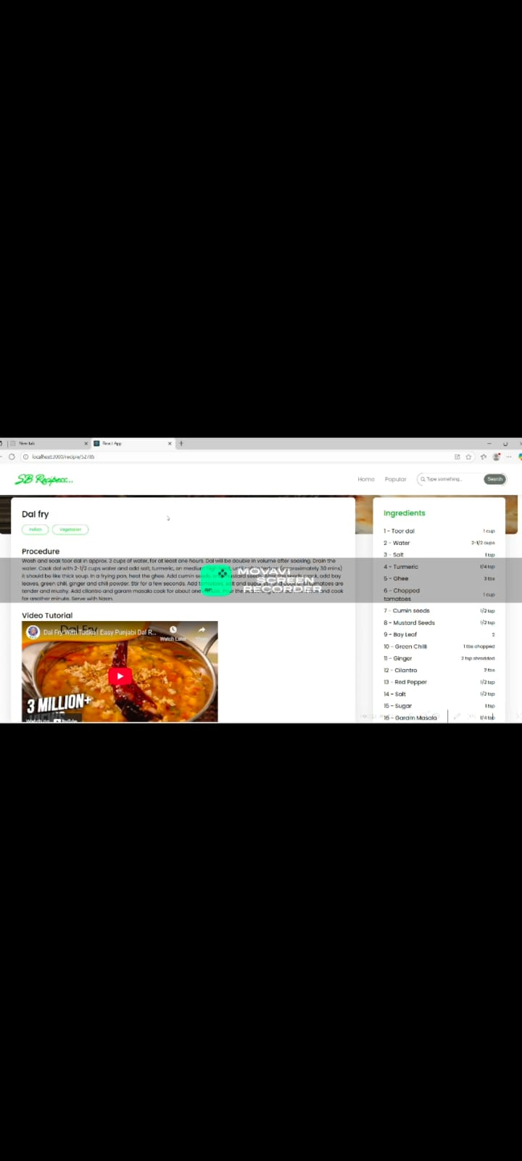

12. Known Issues

- Image upload may be slow on some networks

- Limited offline functionality

- Occasional delay in recipe search on large databases

- Favorites not persisting across devices in some cases

13. Future Enhancements

- AI-based recipe recommendations
- Meal planner with grocery list generation
- Mobile app version

